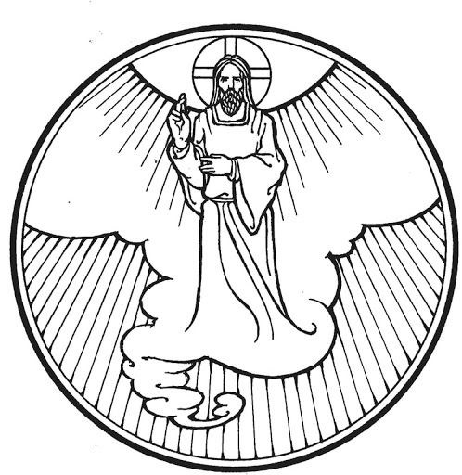

While he was blessing them, he left them and was taken up into heaven. Luke 24:51

The Ascension of Our Lord
May 21, 2023

Welcome! We are glad you are here! In worship, we gather before the almighty God to offer him the praise that is due his name and to be fed by his life-giving Word. This service folder will guide you through our path of worship. If you have any questions, please don’t hesitate to ask an usher or the person sitting next to you. God bless your time in this house of God.

Bathrooms are located in the fellowship hall. A changing table is located in the women’s bathroom.

A worship monitor is to the right as you exit. We encourage children of all ages to participate in our worship. Please bring them into the service. We have a nursery room with toys, books, and other items that you can use with your child.
Before you leave, please sign our guest register. Located on the lectern in the entryway.

OPENING HYMN Jesus, Your Church with Longing Eyes CW 9

M: The grace of our Lord Jesus Christ and the love of God and the fellowship of the Holy Spirit be with you.
C: And also with you.
Confession and Absolution
M: God invites us to come into his presence and worship him with humble and penitent hearts. Therefore, let us acknowledge our sinfulness and ask him to forgive us.
C: Holy and merciful Father, I confess that I am by nature sinful, and that I have disobeyed you in my thoughts, words, and actions. I have done what is evil and failed to do what is good. For this I deserve your punishment both now and in eternity. But I am truly sorry for my sins, and trusting in my Savior Jesus Christ, I pray: Lord have mercy on me, a sinner.
M: God, our heavenly Father, has been merciful to us and has given his only Son to be the atoning sacrifice for our sins. Therefore, as a called servant of Christ and by his authority, I forgive you all your sins in the name of the Father and of the Son and of the Holy Spirit.
C: Amen.

Prayer and Praise
M: In the peace of forgiveness, let us praise the Lord:
C: By grace I’m saved, grace free and boundless;
My soul believe and doubt it not.
Why waver at this word of promise?
Has Scripture ever falsehood taught?
So, then this word must true remain:
By grace you, too, shall heav’n obtain.
PRAYER OF THE DAY
M: Lord Jesus, King of glory, on this day you ascended far above the heavens and at God’s right hand you rule the nations. Leave us not alone, we pray, but grant us the Spirit of truth that at your command and by your power we may be your witnesses in all the world; for you live and reign with the Father and the Holy Spirit, one God, now and forever.
C: Amen.
The Word

FIRST LESSON Acts 1:1-11

PSALM OF THE DAY Psalm 47 (CW pg. 85)

SECOND LESSON Ephesians 1:15-23

GOSPEL ACCLAMATION
M: Alleluia. I will not leave you as orphans; I will come to you. Alleluia.
SEASONAL RESPONSE
C: ♫ By grace to timid hearts that tremble,
In tribulation’s furnace tried –
By grace, despite all fear and trouble,
The Father’s heart is open wide.
Where could I help and strength secure
If grace were not my anchor sure?

GOSPEL Luke 24:44-53
M: This is the word of the Lord.
C: Praise be to you, O Christ!

HYMN OF THE DAY On Christ’s Ascension I Now Build CW 173

SERMON

NICENE CREED
We believe in one God, the Father, the Almighty,
maker of heaven and earth,
of all that is,
seen and unseen.

We believe in one Lord, Jesus Christ, the only Son of God,
eternally begotten of the Father,
God from God, Light from Light, true God from true God,
begotten, not made,
of one being with the Father.
Through him all things were made.
For us and for our salvation, he came down from heaven,
was incarnate of the Holy Spirit and the virgin Mary,
and became fully human.
For our sake he was crucified under Pontius Pilate.
He suffered death and was buried.
On the third day he rose again in accordance with the
Scriptures.
He ascended into heaven
and is seated at the right hand of the Father.
He will come again with glory to judge the living and the dead, and his kingdom will have no end.

We believe in the Holy Spirit,
the Lord, the giver of life,
who proceeds from the Father and the Son,
who in unity with the Father and the Son is worshiped
and glorified, who has spoken through the prophets.
We believe in one holy Christian and apostolic Church.
We acknowledge one baptism for the forgiveness of sins.
We look for the resurrection of the dead
and the life of the world to come. Amen.
OFFERING
We joyfully respond to our Shepherd’s loving care by praising him with all we are and all we have. Bringing an offering is an act of trust in God’s promises to provide and an acknowledgement that “my cup overflows.” A joyful and generous offering is always a wonderful way to show Jesus that he is our greatest treasure and worthy of our praise. May God be praised through our offerings!

PRAYER OF THE CHURCH

M: Jesus Christ, our ascended Lord, give us your blessing as you blessed your disciples, that we may be filled with your power and declare your praise.
You are head over everything for your church;
C: you fill everything in every way.

M: Give us your Spirit of wisdom and revelation so that we may know you better. Enlighten us that we may know the hope of our heavenly inheritance.
You are head over everything for your church;
C: you fill everything in every way.

M: You commissioned your disciples to be your witnesses to the ends of the earth. Send your Holy Spirit on all your people, that we may bear witness to your gospel of repentance and forgiveness, and bring your kingdom of grace to those who live in darkness.
You are head over everything for your church;
C: you fill everything in every way.

M: You rule the world with truth and grace. Govern and guide the leaders of all nations, so that your Word may spread to the ends of the earth, and that we may enjoy security and peace.
You are head over everything for your church;
C: you fill everything in every way.

M: You rule at your Father’s right hand, and all things are under your feet. When dark days come, remind us of your gracious rule over everything for us, the members of your body the Church.
You are head over everything for your church;
C: you fill everything in every way.
Special prayers and intercessions may follow.
M: Listen, Lord, to the thoughts and cares of our hearts.
Silent prayer
M: Lord Jesus Christ, Son of the most high, you sit at the right hand of your Father and rule as Lord over all things in heaven and on earth. Send us your Holy Spirit, give us true servants of your Word, and preserve your kingdom on earth by your power until all your enemies lie under your feet, that we may finally overcome sin and death and enjoy eternal life with you; for you live and reign with the Father in the unity of the Holy Spirit, one true God, forever and ever.
C: Amen.

LORD’S PRAYER
C: Our Father, who art in heaven, hallowed be thy name, thy kingdom come, thy will be done on earth as it is in heaven. Give us this day our daily bread; and forgive us our trespasses, as we forgive those who trespass against us; and lead us not into temptation, but deliver us from evil. For thine is the kingdom and the power and the glory forever and ever. Amen

THE SACRAMENT
These responses mark the beginning of the Sacrament section of the service and lift the worshipers’ hearts in praise. The opening sentences are among the oldest in the Christian liturgy.

M: The Lord be with you.
C: And also with you.
M: Lift up your hearts.
C: We lift them up to the Lord.
M: Let us give thanks to the Lord our God.
C: It is good and right so to do.

M: Praise to the God and Father of our Lord Jesus Christ! In love he has blessed us with every spiritual blessing. He raised Christ from the dead and seated him at his right hand in the heavenly realms and placed all things under his feet for the benefit of the Church. Now have come the salvation and the power and the kingdom of our God and the authority of his Christ. To Him who sits on the throne and to the Lamb be praise and thanks and honor and glory forever and ever.

HOLY, HOLY, HOLY (Sanctus)

C: Holy, holy, holy is the Lord of hosts. The whole earth is full of your glory. You are my God, and I will exalt you. I will give you thanks, for you have become my salvation. Holy, holy, holy is the Lord of hosts. The whole earth is full of your glory.

WORDS OF INSTITUTION

Our Lord Jesus Christ, on the night he was betrayed, took bread; and when he had given thanks, he broke it and gave it to his disciples, saying, “Take and eat; this is my body, which is given for you. Do this in remembrance of me.”

Then he took the cup, gave thanks, and gave it to them, saying, “Drink from it, all of you; this is my blood of the new covenant, which is poured out for you for the forgiveness of sins. Do this, whenever you drink it, in remembrance of me.”
The peace of the Lord be with you always!

C: Amen.

O CHRIST, LAMB OF GOD (Agnus Dei)

C: O Christ, Lamb of God, you take away the sin of the world; have mercy on us. O Christ, Lamb of God, you take away the sin of the world; have mercy on us. O Christ, Lamb of God, you take away the sin of the world; grant us your peace. Amen.

DISTRIBUTION
(To our visitors: As we celebrate Holy Communion, we want you to be able to commune with us! But we also want you to be aware that we believe, from Scripture, that when you commune with a group of Christians, you are indicating you are in doctrinal agreement. Therefore, if you are not a member of our church or of a church in fellowship with us, we kindly ask you to refrain from communing with us until you have had a chance to declare your agreement with what we teach. If you would like to take such a step or would like further explanation on this, please don’t hesitate to speak to the pastor after the service.)

COMMUNION HYMN A Hymn of Glory Let Us Sing CW 171

SONG OF SIMEON

C: Lord, now you let your servant depart in peace according to your word. For my eyes have seen your salvation, which you have prepared before the face of all people, a light to lighten the Gentiles and the glory of your people Israel.

O God the Father, source of all goodness, in your loving kindness through him you have given us pardon and peace. We also pray that you rule in our hearts and minds by your Holy Spirit so that we willingly serve you day after day, through Jesus Christ, our Lord, who lives and reigns with you and the Holy Spirit, one God, now and forever.

C: Amen.

BLESSING

Brothers and sisters, go in peace. Live in harmony with one another. Serve the Lord with gladness.

The Lord bless you and keep you.
The Lord make his face shine on you and be gracious to you.
The Lord look on you with favor and give you peace.

C: Amen. Amen. Amen.

CLOSING HYMN Crown Him with Many Crowns CW 341

Come worship with us again!
Next Sunday, May 28TH - 2:00 pm

VACANCY PASTOR

Christopher Hoppe, Pastor stjohnluthvaca@outlook.com
(920) 652-4003 www.stjohnvacaville.org
christopherhpp@gmail.com

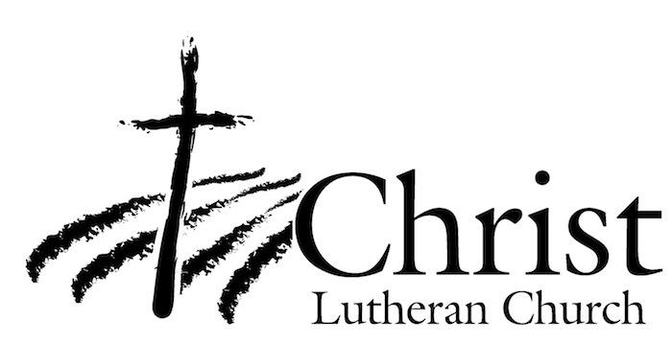
13009 N. Elderberry Ct.
Lodi, CA 95242
www.christlodi.org
209-368-6250
WELCOME TO CHRIST EV. LUTHERAN CHURCH!
We preach a message of forgiveness, hope and peace
through the death and resurrection of Jesus Christ.
Families and individuals of all ages will find opportunities
both to grow and to serve.

Our mission statement:
Look what Christ is doing!
He binds us together in fellowship
He gathers us in for worship
He builds us up for service
He sends us out with the gospel

“Now you are the body of Christ,
and each one of you is a part of it.”
(1 Corinthians 12:27)

